## User Testing

//Dokumen yang berisikan tentang bagaimana untuk melakukan test berdasarkan scenario / business requirement yang ditentukan

**Part 2**

1. Berapa banyak customer yang registrasi di platform setiap harinya?
2. Expected Output

| registration_date | jumlah_customer |
| --- | --- |
| 2023-11-01 | 1 |
| 2023-11-02 | 1 |
| 2023-11-03 | 1 |
| 2023-11-04 | 1 |
| 2023-11-05 | 1 |

1. Output

Kami membuat perintah SELECT pada tabel Customer dengan function Count untuk menghitung jumlah customer, berikut adalah query yang kami buat:

SELECT

Registration_date,

COUNT(id_customer) AS Jumlah_Customer_Regristrasi

FROM aqueous-freedom-398208.OFD_Team_1.Customer

GROUP BY registration_date

ORDER BY registration_date ASC;

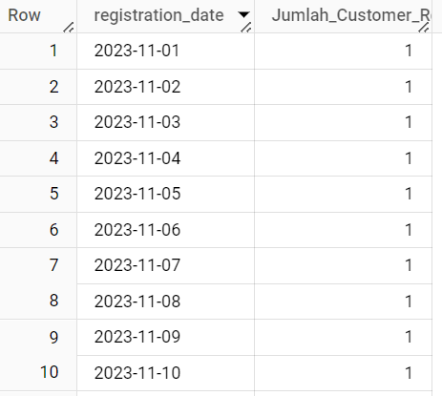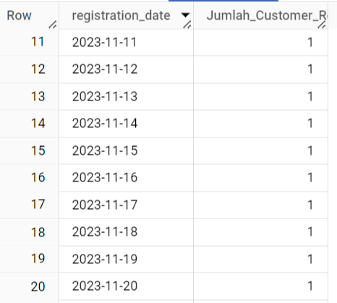

1. Status : **pass**
2. Berapa banyak jumlah order yang terbentuk setiap harinya?
   1. Expected Output

| order_date | Jumlah_order |
| --- | --- |
| 2023-11-01 | 3 |
| 2023-11-02 | 1 |
| 2023-11-03 | 1 |
| 2023-11-04 | 1 |

* 1. Output

Kami membuat perintah SELECT pada tabel order dengan function COUNT untuk menghitung jumlah order, berikut query yang kami buat :

SELECT

Order_date,

COUNT(id_order) AS Jumlah_Order

FROM aqueous-freedom-398208.OFD_Team_1.Order

GROUP BY order_date

ORDER BY order_date ASC;

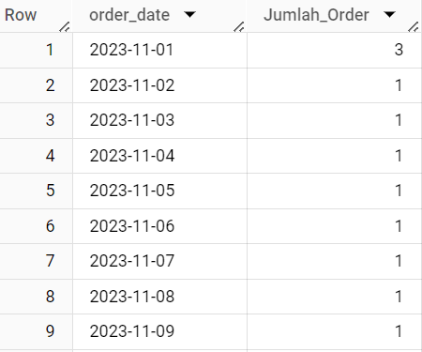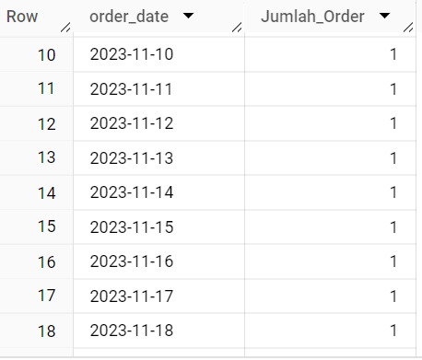

* 1. Status: **Pass**

1. Berapa keuntungan yang didapat dari OK! Food Delivery setiap harinya?
   1. Expected Output

| Tanggal | Keuntungan |
| --- | --- |
| 2023-11-01 | 144000 |
| 2023-11-02 | 36000 |
| 2023-11-03 | 105000 |
| 2023-11-04 | 36000 |
| 2023-11-05 | 70000 |

* 1. Output

Kami membuat perintah SELECT dengan menjumlahkan Quantity dikali Price untuk menghasilkan keuntungan, berikut query yang kami buat:

SELECT

o.order_date AS Tanggal,

SUM(o.quantity * f.price) AS Keuntungan

FROM aqueous-freedom-398208.OFD_Team_1.Order o

INNER JOIN aqueous-freedom-398208.OFD_Team_1.Food f ON o.fk_food_id = f.id_food

GROUP BY o.order_date

ORDER BY o.order_date ASC;

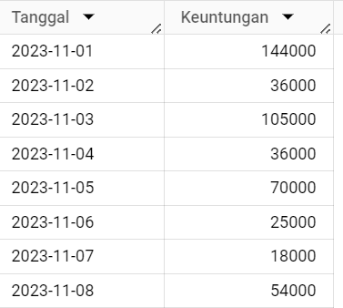

* 1. Status: **Pass**

1. Berapa *average spending* 1 orang customer setiap harinya dalam 1 bulan?
2. Expected Output

| nama_customer | Bulan | Average_daily_spend |
| --- | --- | --- |
| Badu | 2023-11-01 | 18000 |
| Budi | 2023-12-01 | 43000 |
| Coki | 2024-01-01 | 80000 |
| Danu | 2024-02-01 | 18000 |

1. Output

Kami membuat perintah SELECT dengan metode subquery untuk mempermudah menghitung average_daily_spend, berikut query yang kami buat:

WITH MonthlyTransactions AS (

SELECT

DATE_TRUNC(o.order_date, MONTH) AS bulan,

o.fk_customer_id,

COUNT(*) AS jumlah_transaksi

FROM `aqueous-freedom-398208.OFD_Team_1.Order` o

GROUP BY bulan, o.fk_customer_id

),

MonthlyExpenditures AS (

SELECT

DATE_TRUNC(o.order_date, MONTH) AS bulan,

o.fk_customer_id,

SUM(f.price * o.quantity) AS total_pengeluaran

FROM `aqueous-freedom-398208.OFD_Team_1.Order` o

JOIN `aqueous-freedom-398208.OFD_Team_1.Food` f ON o.fk_food_id = f.id_food

GROUP BY

bulan, o.fk_customer_id

),

CustomerData AS (

SELECT

c.id_customer,

c.name AS nama_customer

FROM

`aqueous-freedom-398208.OFD_Team_1.Customer` c

)

SELECT

cd.nama_customer,

mt.bulan AS Bulan,

COALESCE(ROUND(me.total_pengeluaran / mt.jumlah_transaksi, 2), 0) AS rata_rata_pengeluaran_per_transaksi

FROM

MonthlyTransactions mt

LEFT JOIN

MonthlyExpenditures me ON mt.bulan = me.bulan AND mt.fk_customer_id = me.fk_customer_id

JOIN

CustomerData cd ON mt.fk_customer_id = cd.id_customer

ORDER BY

Bulan ASC, cd.nama_customer ASC;

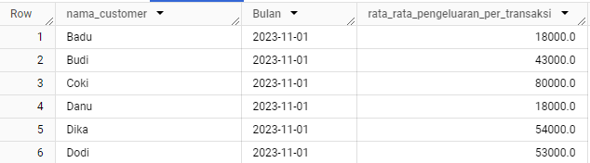

1. Status: **Pass**

**Part 3**

1. Apakah semua data yang masuk komplit? Semua column/row terisi ?  
     
   **A. Table Customer**

a. Expected Output

| Column | Data Type |
| --- | --- |
| id_customer | int64 |
| name | object |
| registration_date | dbdate |
| contact | object |

b. output   
 Pada table Customer kami membuat dataset mandiri (dummy) kemudian kami melakukan pengecekan data menggunakan jupyter lab dengan sintax  
df2.info()

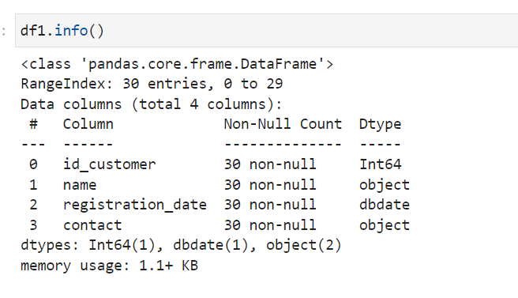

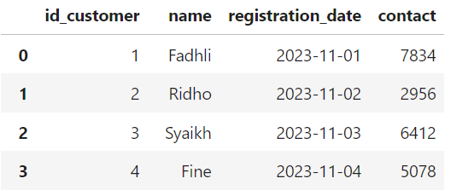

B. **Table Order** a. Expected Output

| Column | Data Type |
| --- | --- |
| id_order | int64 |
| fk_customer_id | int64 |
| order_date | dbdate |
| fk_food_id | Int64 |
| quantity | Int64 |
| status | Object |

b. output   
 Pada table Order kami membuat dataset mandiri (dummy) kemudian kami melakukan pengecekan data menggunakan jupyter lab dengan sintax  
df2.info()

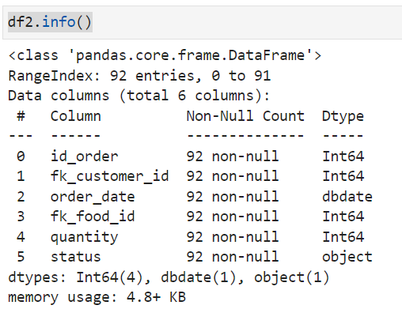

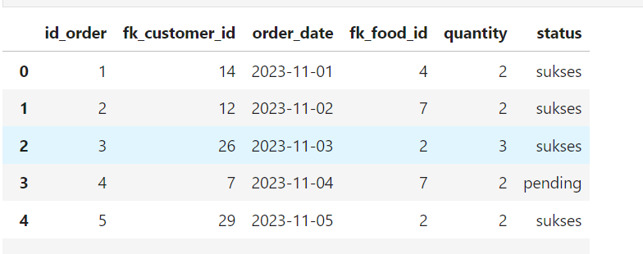

C. **Table Food**  
 a. Expected Output

| Column | Data Type |
| --- | --- |
| id_food | int64 |
| food_name | Object |
| fk_resto_id | Int64 |
| Price | Int64 |

b. output   
 Pada table Food kami membuat dataset mandiri (dummy) kemudian kami melakukan pengecekan data menggunakan jupyter lab dengan sintax  
df3.info()

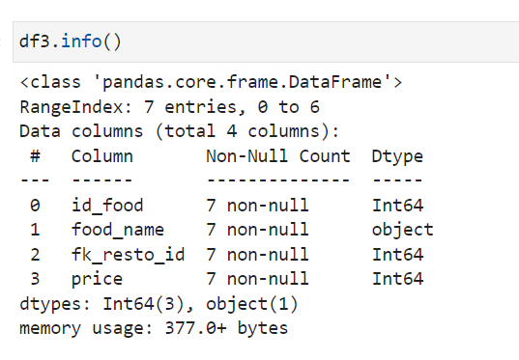

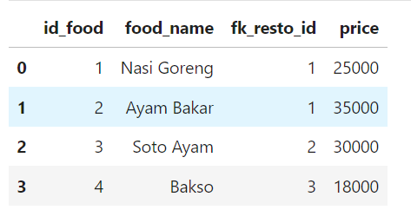  
  
D. **Table Restaurant**  
 a. Expected Output

| Column | Data Type |
| --- | --- |
| id_restaurant | int64 |
| restaurant_name | Object |
| City | Object |

b. output   
 Pada table Restaurant kami membuat dataset mandiri (dummy) kemudian kami melakukan pengecekan data menggunakan jupyter lab dengan sintax  
df4.info()

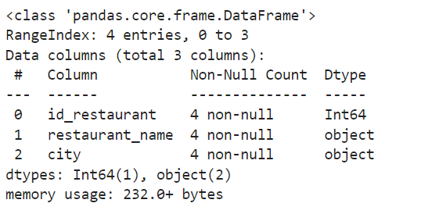

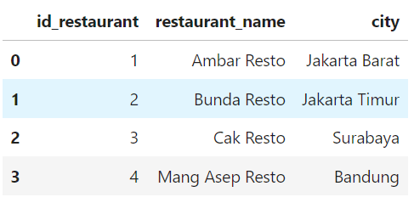  
Status : **PASS**

1. Apakah ada data type yang tidak sesuai..?

##### **Jawab :**

##### Berdasarkan penjelasan pada soal nomor 1, dapat disimpulkan bahwa tidak ada data yang tidak sesuai dengan kondisi yang direncanakan. Semua data telah sesuai dengan persyaratan yang ditetapkan

## Apakah ada pertanyaan utama tim business development sebelumnya masih bisa terjawab? Jawab : Terkait pertanyaan-pertanyaan tim pengembangan bisnis, semuanya telah dijawab dan tidak ada lagi yang tertinggal.

## 

**Part 4**

1. Segmentasi customer berdasarkan jumlah order dan uang yang sudah dikeluarkan di platform OK! Food Delivery?
   1. Expected output

| name | total_order | total_spend | level |
| --- | --- | --- | --- |
| Badu | 2 | 108000 | Supreme |
| Beri | 2 | 50000 | Grandmaster |
| Budi | 2 | 36000 | Master |
| Coki | 2 | 80000 | Supreme |

* 1. Output

Pada tabel berikut kami menghitung total_spend untuk setiap costumer dan memberikan level sesuai dengan total spend masing masing customer

SELECT

Kategori.name,

kategori.total_order,

kategori.total_spend,

CASE

WHEN kategori.total_order > 3 AND kategori.total_spend >= 80000 THEN 'Big Spender'

WHEN kategori.total_spend < 10000 THEN 'Beginner'

WHEN kategori.total_spend < 40000 THEN 'Master'

WHEN kategori.total_spend < 80000 THEN 'Grandmaster'

ELSE 'Supreme' END level

FROM

(

SELECT

c.name,

COUNT(*) AS total_order,

SUM(f.price*o.quantity) AS total_spend

FROM aqueous-freedom-398208.OFD_Team_1.Order o

INNER JOIN aqueous-freedom-398208.OFD_Team_1.Food f ON f.id_food = o.fk_food_id

INNER JOIN aqueous-freedom-398208.OFD_Team_1.Customer c ON c.id_customer = o.id_order

GROUP BY 1

) AS kategori

ORDER BY 1;

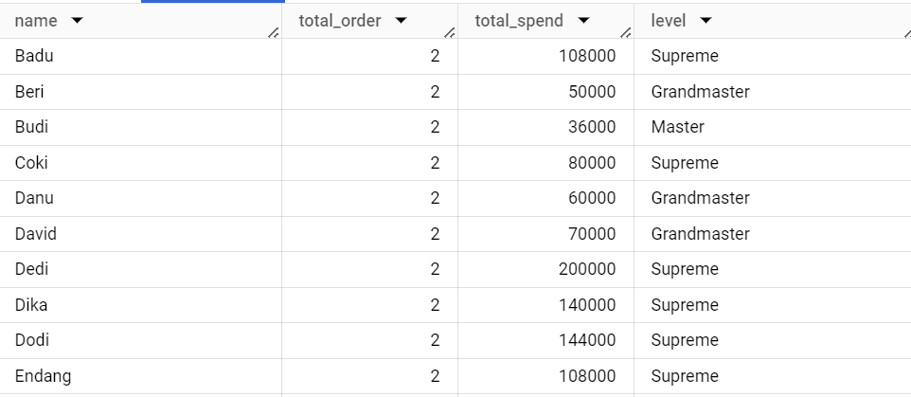

* 1. Status: **Pass**

1. Semua transaksi yang masih ‘menggantung’ dari D-1 agar bisa di*follow up* oleh tim operational / *customer service*
2. Expected Output

| Name | order_date | status | contact |
| --- | --- | --- | --- |
| Fine | 2023-11-04 | pending | 5078 |
| Beri | 2023-11-06 | pending | 8645 |
| Budi | 2023-11-07 | pending | 3091 |
| Danu | 2023-11-11 | pending | 4276 |

1. Ouput

Kami membuat data dummy yang kemudian kami manipulasi menggunakan perintah SELECT pada tabel customer dengan menggunakan function WHERE guna mempermudah siapa saja yang berstatus pending

SELECT

c.name,

o.order_date,

o.status,

c.contact

FROM aqueous-freedom-398208.OFD_Team_1.Customer c

JOIN aqueous-freedom-398208.OFD_Team_1.Order o ON c.id_customer = o.id_order

WHERE o.status = 'pending'

ORDER BY o.order_date ASC;

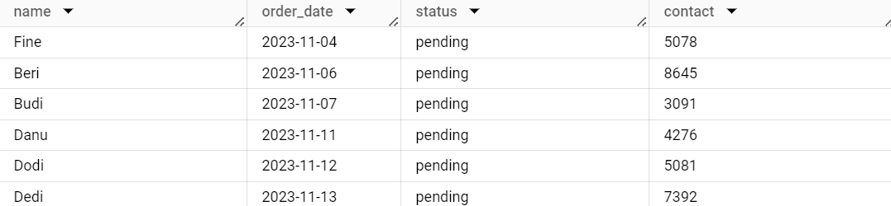

1. Status : **PASS**

**Part 5 (Dataset Tim-1)**

1. *Revenue harian per kota*
2. Expected output

| order_date | city | daily_revenue |
| --- | --- | --- |
| 2023-11-01 | Surabaya | 36000 |
| 2023-11-02 | Bandung | 36000 |

1. Output

SELECT

o.order_date,

r.city,

SUM(f.price * o.quantity) AS daily_revenue

FROM `aqueous-freedom-398208.OFD_Team_1.Order` o

INNER JOIN`aqueous-freedom-398208.OFD_Team_1.Food` f ON o.fk_food_id = f.id_food

INNER JOIN `aqueous-freedom-398208.OFD_Team_1.Restaurant` r ON f.fk_resto_id = r.id_restaurant

GROUP BY order_date,city

ORDER BY order_date,city;

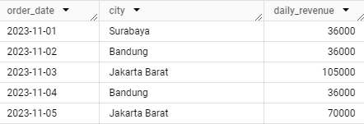

1. Status: **Pass**
2. *Customer segmentation report harian*
3. Expected output

| id_customer | name | today_date | last_order | total_transaction | total_spending | segmentasi |
| --- | --- | --- | --- | --- | --- | --- |
| 1 | Arif | 2024-02-13 | 2024-01-14 | 1 | 75000 | New |
| 2 | Budi | 2024-02-13 | 2024-01-14 | 1 | 70000 | New |

1. Output

drop table if exists`aqueous-freedom-398208.OFD_Team_1.costumer_segmentation`;

create table `aqueous-freedom-398208.OFD_Team_1.costumer_segmentation` AS

WITH tabel AS (

SELECT

id_customer,

c.name,

DATE_SUB(CURRENT_DATE(), INTERVAL 30 DAY) AS last_order_date,

DATE_DIFF(o.order_date, c.registration_date, DAY) AS days_since_registration,

COUNT(*) OVER (PARTITION BY c.name) AS total_transaction,

SUM(f.price * o.quantity) OVER (PARTITION BY c.name) AS total_spending,

ROW_NUMBER() OVER (PARTITION BY c.name ORDER BY o.order_date DESC) AS row_num,

LAG(o.order_date) OVER (PARTITION BY c.name ORDER BY o.order_date) AS prev_order_date

FROM aqueous-freedom-398208.OFD_Team_1.Customer c

LEFT JOIN aqueous-freedom-398208.OFD_Team_1.Order o ON c.id_customer = o.fk_customer_id

LEFT JOIN aqueous-freedom-398208.OFD_Team_1.Food f ON f.id_food = o.fk_food_id AND o.order_date >= DATE_SUB(CURRENT_DATE(), INTERVAL 30 DAY)

WHERE c.registration_date <= DATE_SUB(CURRENT_DATE(), INTERVAL 30 DAY)

AND o.order_date >= DATE_SUB(CURRENT_DATE(), INTERVAL 30 DAY) -- Tambahkan kondisi untuk memfilter tanggal pesanan

)

SELECT

id_customer,

name,

DATE_SUB(CURRENT_DATE(), INTERVAL 0 DAY) AS today_date,

DATE_SUB(CURRENT_DATE(), INTERVAL 30 DAY) AS last_order,

total_transaction,

total_spending,

CASE

WHEN total_spending >= 500001 THEN 'Big Spender'

WHEN total_transaction <= 1 THEN 'New'

WHEN total_transaction <= 5 THEN 'Good'

WHEN total_transaction <= 10 THEN 'Potential'

ELSE 'Loyalist'

END AS segmentation

FROM tabel

ORDER BY last_order_date DESC;

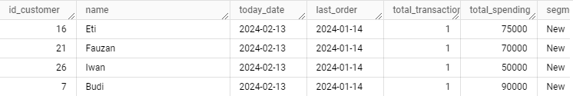

1. Status: **Pass**
2. *Growth harian dan kontribusi revenue perkota*
3. Expected output

**Growth**

| Kota | Tanggal | Revenue_hari_kemarin | Revenue | Growth_Rate_Precentage |
| --- | --- | --- | --- | --- |
| Bandung | 2023-11-02 | 0 | 36000 | null |
| Bandung | 2023-11-04 | 36000 | 36000 | 0% |

**Kontribusi**

| date | city | total_revenue | contribution |
| --- | --- | --- | --- |
| 2023-11-01 | Surabaya | 36000 | 100 |
| 2023-11-02 | Bandung | 36000 | 100 |

1. Output

**Growth**

drop table if exists `aqueous-freedom-398208.OFD_Team_1.growth_harian_perkota`;

create table `aqueous-freedom-398208.OFD_Team_1.growth_harian_perkota` AS

WITH DailyRevenue AS (

SELECT

r.city AS Kota,

o.order_date AS Tanggal,

SUM(o.quantity * f.price) AS Revenue,

LAG(SUM(o.quantity * f.price), 1) OVER (PARTITION BY r.city ORDER BY o.order_date) AS Revenue_Hari_Kemarin,

LAG(SUM(o.quantity * f.price), 2) OVER (PARTITION BY r.city ORDER BY o.order_date) AS Revenue_Dua_Hari_Sebelumnya

FROM

`aqueous-freedom-398208.OFD_Team_1.Order` o

INNER JOIN

`aqueous-freedom-398208.OFD_Team_1.Food` f ON o.fk_food_id = f.id_food

INNER JOIN

`aqueous-freedom-398208.OFD_Team_1.Customer` c ON o.fk_customer_id = c.id_customer

INNER JOIN

`aqueous-freedom-398208.OFD_Team_1.Restaurant` r ON f.fk_resto_id = r.id_restaurant

GROUP BY

r.city, o.order_date

)

SELECT

Kota,

Tanggal,

COALESCE(Revenue_Hari_Kemarin, Revenue_Dua_Hari_Sebelumnya, 0) AS Revenue_Hari_Kemarin,

Revenue,

CASE

WHEN COALESCE(Revenue_Hari_Kemarin, Revenue_Dua_Hari_Sebelumnya) IS NULL THEN NULL

ELSE CONCAT(ROUND(((Revenue - COALESCE(Revenue_Hari_Kemarin, Revenue_Dua_Hari_Sebelumnya)) / NULLIF(COALESCE(Revenue_Hari_Kemarin, Revenue_Dua_Hari_Sebelumnya), 0)) * 100, 2), '%')

END AS Growth_Rate_Percentage

FROM

DailyRevenue

ORDER BY

Kota, Tanggal;

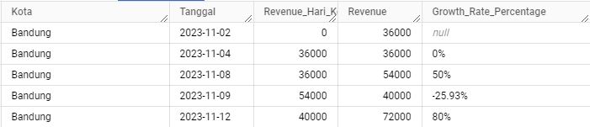

**Kontribusi**

drop table if exists `aqueous-freedom-398208.OFD_Team_1.kontribusi_harian_perkota`;

CREATE TABLE `aqueous-freedom-398208.OFD_Team_1.kontribusi_harian_perkota` AS

WITH daily_total AS (

SELECT

order_date,

SUM(f.price * o.quantity) AS total_revenue_all_cities

FROM `aqueous-freedom-398208.OFD_Team_1.Order` o

JOIN `aqueous-freedom-398208.OFD_Team_1.Food` f ON o.fk_food_id = f.id_food

JOIN `aqueous-freedom-398208.OFD_Team_1.Restaurant` r ON f.fk_resto_id = r.id_restaurant

GROUP BY

order_date

)

SELECT

o.order_date AS date,

r.city,

SUM(f.price * o.quantity) AS total_revenue,

ROUND((SUM(f.price * o.quantity) / dt.total_revenue_all_cities) * 100, 2) AS contribution

FROM `aqueous-freedom-398208.OFD_Team_1.Order` o

JOIN `aqueous-freedom-398208.OFD_Team_1.Food` f ON o.fk_food_id = f.id_food

JOIN `aqueous-freedom-398208.OFD_Team_1.Restaurant` r ON f.fk_resto_id = r.id_restaurant

JOIN daily_total dt ON o.order_date = dt.order_date

GROUP BY

r.city, o.order_date, dt.total_revenue_all_cities

ORDER BY

o.order_date, r.city;

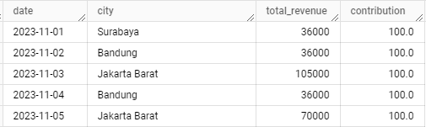

1. Status: **Pass**

**Part 5 (Dataset CodingID)**

1. *Revenue harian per kota*
2. Expected output

| transaction_date | city | daily_revenue |
| --- | --- | --- |
| 2024-01-02 | surabaya | 223052 |
| 2024-01-03 | bandung | 111359 |
| 2024-01-04 | surabaya | 277131 |
| 2024-01-05 | bandung | 171451 |
| 2024-01-06 | jakarta | 291440 |

1. Output

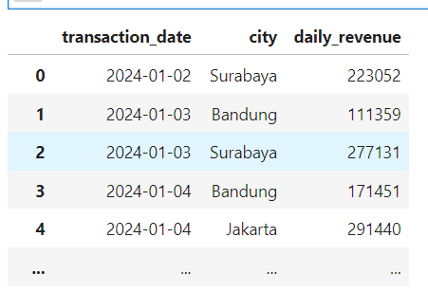

SELECT

t.transaction_date,

r.kota AS city,

SUM(t.price) AS daily_revenue

FROM`aqueous-freedom-398208.ok_food_dataset.transaction_2024` t

INNER JOIN`aqueous-freedom-398208.ok_food_dataset.resto` r ON t.resto_id = r.id

GROUP BY t.transaction_date, r.kota

ORDER BY t.transaction_date, r.kota;

1. Status: **Pass**
2. *Customer segmentation report harian*
3. Expected output

| customer _id | name | today _date | last_order | total_transaction | total_spending | segmentation |
| --- | --- | --- | --- | --- | --- | --- |
| 1 | budi | 2024-02-13 | 2024-01-14 | 2 | 314714 | Good |

1. Output  
   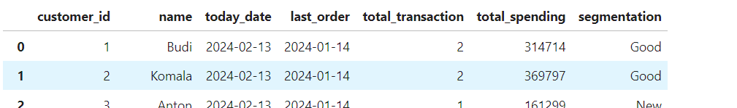

drop table if exists `aqueous-freedom-398208.OFD_Team_1.coding_id_customer_segmentasi`;

CREATE TABLE `aqueous-freedom-398208.OFD_Team_1.coding_id_customer_segmentasi`as

WITH tabel AS (

SELECT

c.id AS customer_id,

c.name,

DATE_SUB(CURRENT_DATE(), INTERVAL 30 DAY) AS last_order_date,

COUNT(t.id) AS total_transaction,

COALESCE(SUM(t.price), 0) AS total_spending

FROM aqueous-freedom-398208.ok_food_dataset.customer c

LEFT JOIN aqueous-freedom-398208.ok_food_dataset.transaction_2024 t ON c.id = t.customer_id

WHERE t.transaction_date >= DATE_SUB(CURRENT_DATE(), INTERVAL 30 DAY)

GROUP BY c.id, c.name

)

SELECT

customer_id,

name,

DATE_SUB(CURRENT_DATE(), INTERVAL 0 DAY) AS today_date,

DATE_SUB(CURRENT_DATE(), INTERVAL 30 DAY) AS last_order,

total_transaction,

total_spending,

CASE

WHEN total_spending >= 500001 THEN 'Big Spender'

WHEN total_transaction <= 1 THEN 'New'

WHEN total_transaction <= 5 THEN 'Good'

WHEN total_transaction <= 10 THEN 'Potential'

ELSE 'Loyalist'

END AS segmentation

FROM tabel

ORDER BY last_order_date DESC;

1. Status: **Pass**
2. *Growth harian dan kontribusi revenue perkota*
3. Expected output
4. *Growth harian*

| kota | tanggal | *revenue_hari_kemarin* | *revenue* | *Growt_pescentage* |
| --- | --- | --- | --- | --- |
| *bandung* | *2024-01-03* | *0* | *111359* | *none* |

1. *kontribusi revenue perkota*

| *date* | *city* | *total_revenue* | *contribution* |
| --- | --- | --- | --- |
| *2024-01-02* | *Surabaya* | *223052* | *100.0* |
| *2024-01-03* | *Bandung* | *111359* | *29.0* |
| *2024-01-03* | *Surabaya* | *277131* | *71.0* |

1. Output
2. ***Growth harian***

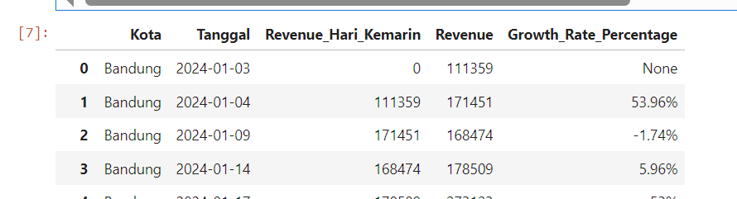

drop table if exists `aqueous-freedom-398208.OFD_Team_1.coding_id__growth_harian`;

CREATE TABLE `aqueous-freedom-398208.OFD_Team_1.coding_id__growth_harian`as

WITH DailyRevenue AS (

SELECT

r.kota AS Kota,

t.transaction_date AS Tanggal,

SUM(t.price) AS Revenue,

LAG(SUM(t.price), 1) OVER (PARTITION BY r.kota ORDER BY t.transaction_date) AS Revenue_Hari_Kemarin,

LAG(SUM(t.price), 2) OVER (PARTITION BY r.kota ORDER BY t.transaction_date) AS Revenue_Dua_Hari_Sebelumnya

FROM

`aqueous-freedom-398208.ok_food_dataset.transaction_2024` t

INNER JOIN

`aqueous-freedom-398208.ok_food_dataset.resto` r ON t.resto_id = r.id

GROUP BY

r.kota, t.transaction_date

)

SELECT

Kota,

Tanggal,

COALESCE(Revenue_Hari_Kemarin, Revenue_Dua_Hari_Sebelumnya, 0) AS Revenue_Hari_Kemarin,

Revenue,

CASE

WHEN COALESCE(Revenue_Hari_Kemarin, Revenue_Dua_Hari_Sebelumnya) IS NULL THEN NULL

ELSE CONCAT(ROUND(((Revenue - COALESCE(Revenue_Hari_Kemarin, Revenue_Dua_Hari_Sebelumnya)) / NULLIF(COALESCE(Revenue_Hari_Kemarin, Revenue_Dua_Hari_Sebelumnya), 0)) * 100, 2), '%')

END AS Growth_Rate_Percentage

FROM

DailyRevenue

ORDER BY

Kota, Tanggal;

1. **Kontribusi harian**

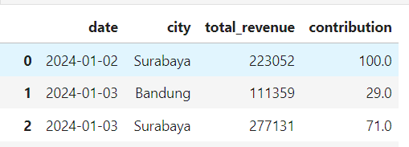

drop table if exists `aqueous-freedom-398208.OFD_Team_1.coding_id_kontribusi_harian_perkota`;

CREATE TABLE `aqueous-freedom-398208.OFD_Team_1.coding_id_kontribusi_harian_perkota`as

WITH city_daily_revenue AS (

SELECT

t.transaction_date AS date,

r.kota AS city,

SUM(t.price) AS total_revenue

FROM

`aqueous-freedom-398208.ok_food_dataset.transaction_2024` t

INNER JOIN

`aqueous-freedom-398208.ok_food_dataset.resto` r ON t.resto_id = r.id

GROUP BY

t.transaction_date, r.kota

),

daily_total AS (

SELECT

transaction_date AS order_date,

SUM(price) AS total_revenue_all_cities

FROM

`aqueous-freedom-398208.ok_food_dataset.transaction_2024`

GROUP BY

transaction_date

)

SELECT

cdr.date,

cdr.city,

cdr.total_revenue,

ROUND((cdr.total_revenue / dt.total_revenue_all_cities) * 100, 0) AS contribution

FROM

city_daily_revenue AS cdr

JOIN

daily_total AS dt ON cdr.date = dt.order_date

ORDER BY

cdr.date, cdr.city;

1. Status: **Pass**